Sept. 22, 2016 PrintAhead 2.0

We made a decision to incorporate the Luxand SDK. The next version of PrintAhead is going to further simplify operation and also enhance success rate. **My goal is that after the set-up screen is done, the work screen will open between 90-100% ready for print for those who do not do profile.**

**Texture ($100) already performed**

1. As we have now combined shape and texture dots, sometimes the texture has edges, which *show up in print. We need to do a better transition on the edges.*

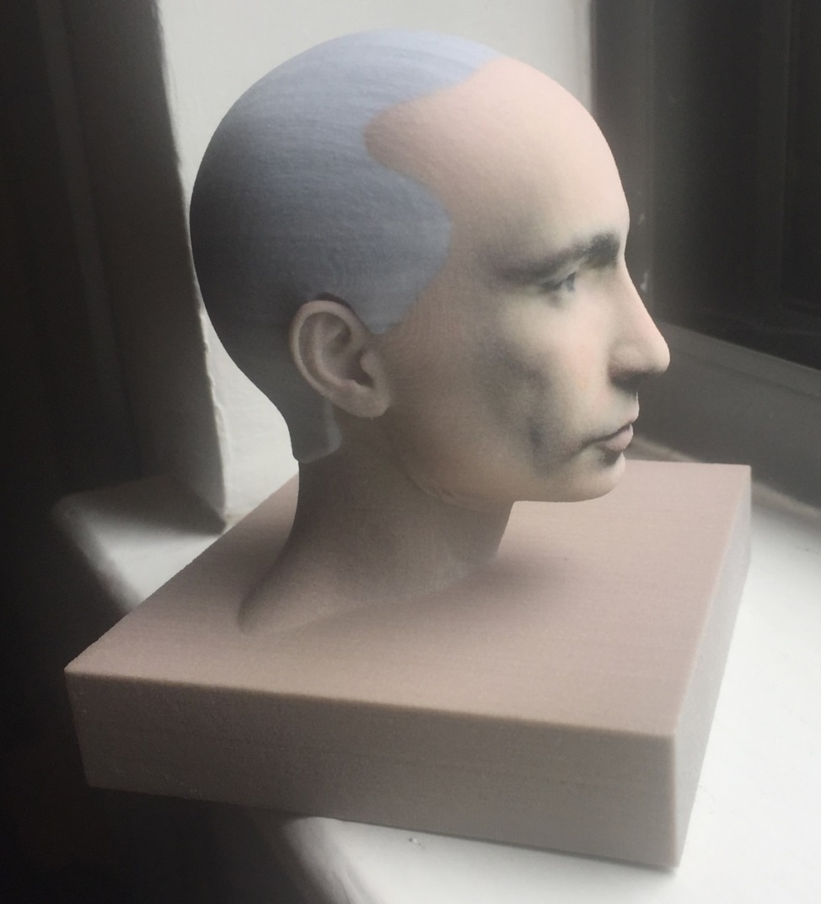

Current condition:

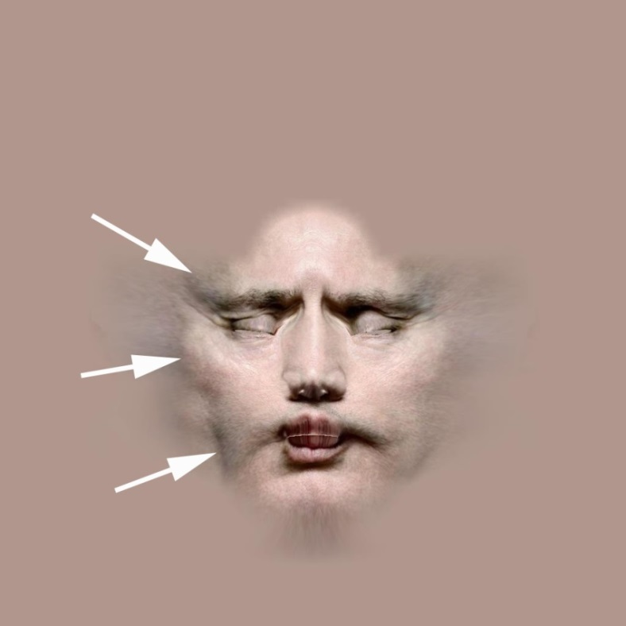

Desired condition:

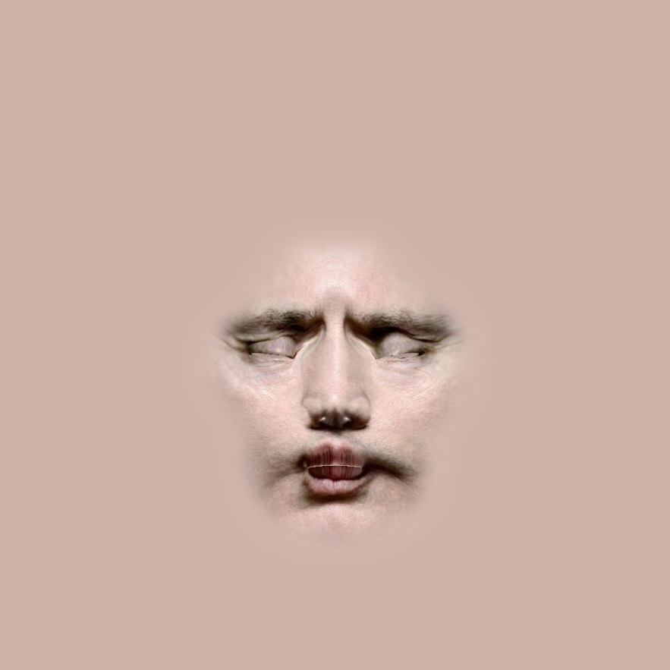

Another example:

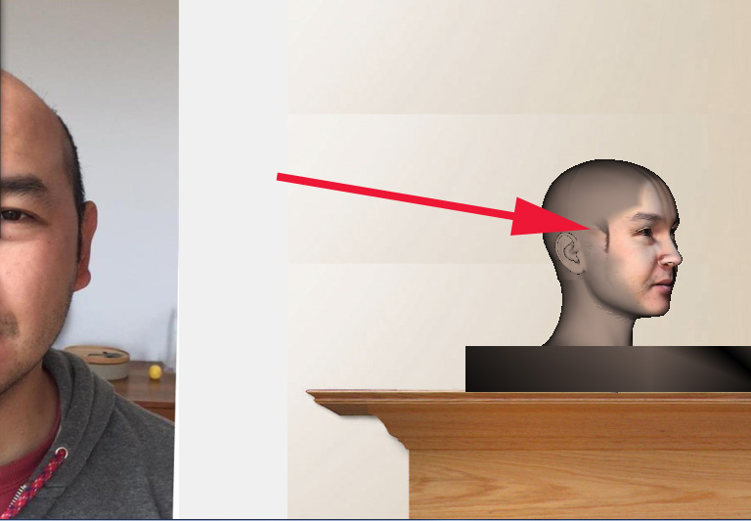

1. When user first selects an accessory and then a hair, accessory disappears.

Desired condition: should stay on

1. In Parts Library add 3 sliders as shown:

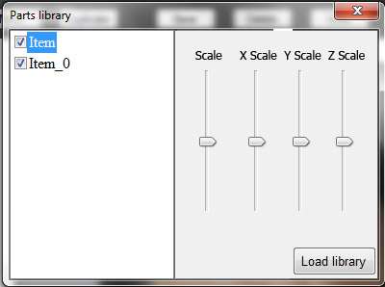

**Age Slider ($80)**

Given that we no longer have a child button, both male and female can be made older AND younger via modified Age slider. When user slides to the (+) it will morph value to Old and Fat. When user slides to (-), it will morph to Child and negative fat.

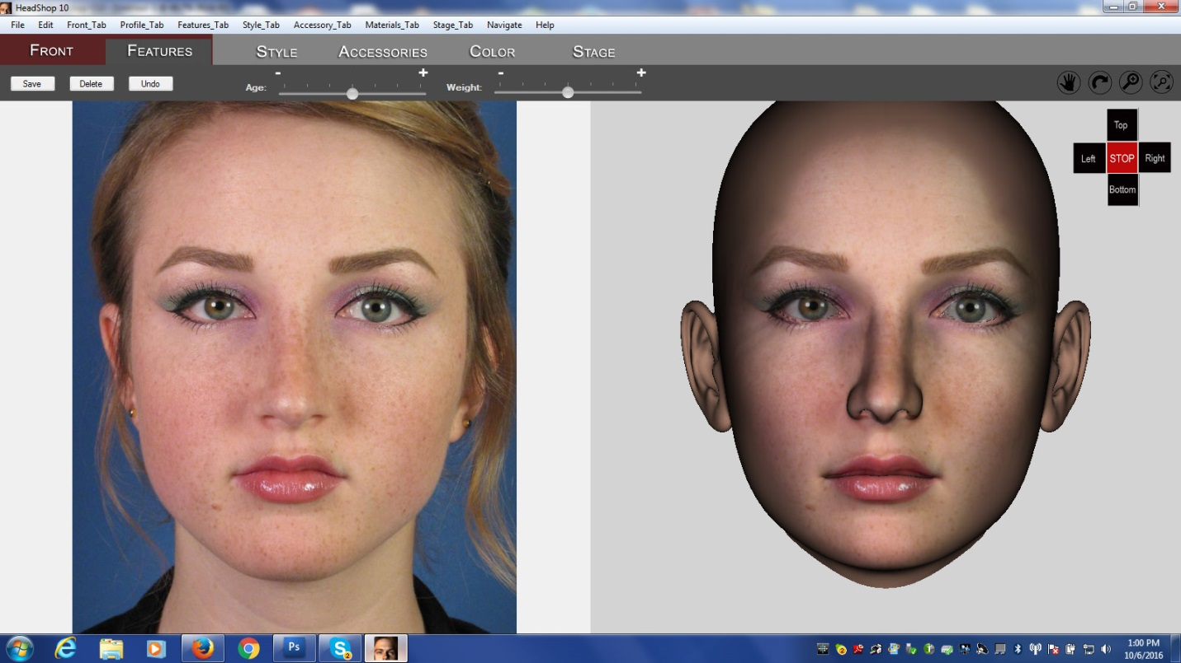

Slider default is the middle (Fem and Male)

**Revised Print Process ($?)**

PrintAhead will be distributed in one version: PrintAhead 2.0: Fully functioning, except for the following:

1. No Export or Save of any kind (quoted out)
2. When Printing (color or b/w) heads, a $X dollar charge will apply to each print (each push of the print button). The interface will bring up PayPal and user has to pay $X before the print is allowed. (I should be allowed to adjust the price somewhere in the app).

This may require you to look into the PayPal API – not sure how this will affect how much work it will be for you. Please let’s discuss!

1. Default position of smoothen. After finished calculations, the default position of smoothen should be at 50% (looks better in results).

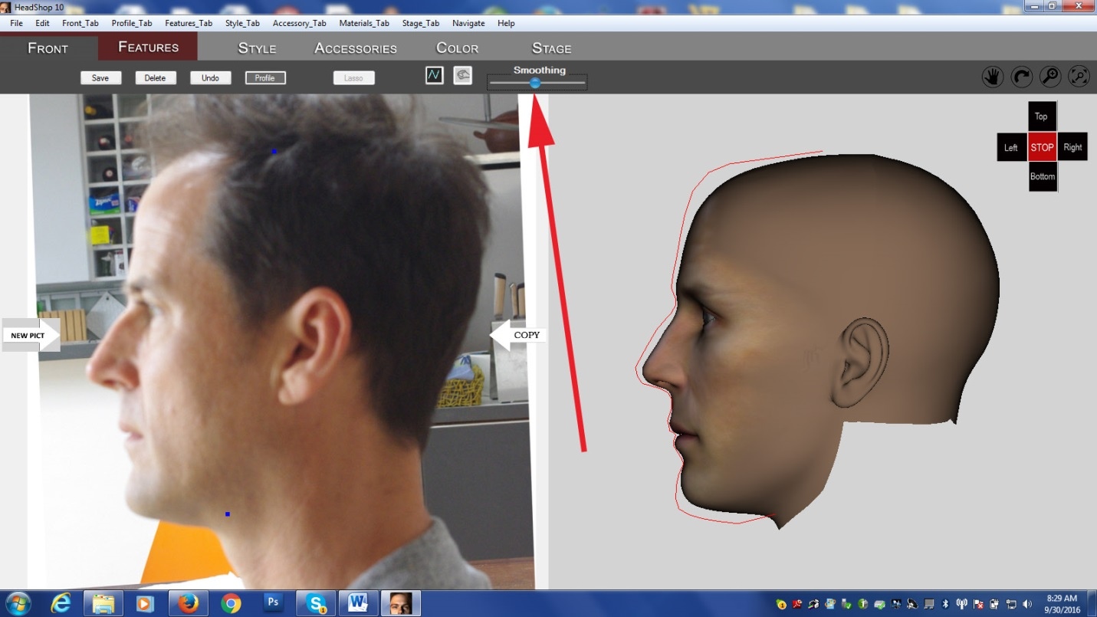

**Fixes to PrintAhread 10.20 ($100)**

1. Eliminate “Accessories” tab. The head needs come with the male or female neck attached right at the Front Tab

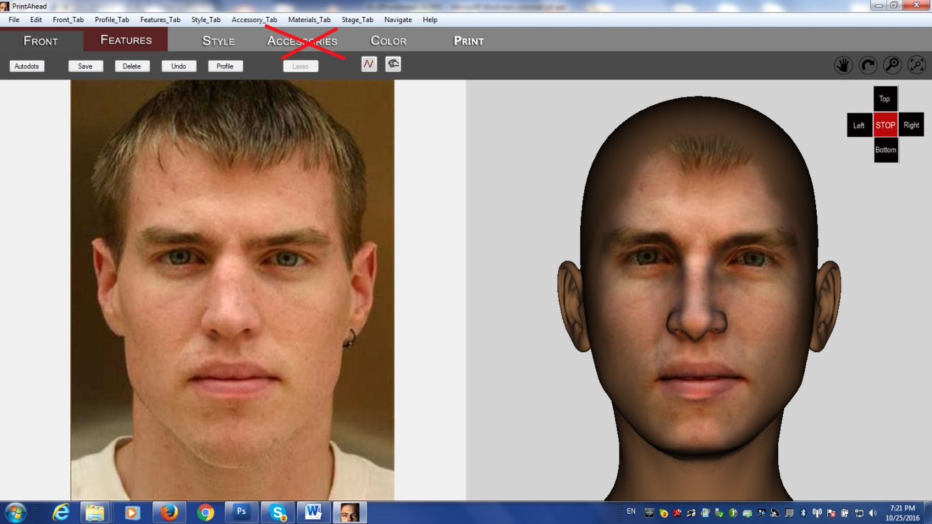

1. I noticed that the Style and Stage library items draw from the Library in User/Public/Abalone folder. It should be really drawing from the Library folder within the PrintAhead folder.
2. As noted earlier, loading hair after the neck should not make any disappear regardless of the order of loading.
3. All Export and Save functions need to be taken out. Once user pays PayPal, a single file is created (either STL for black/white output or zip file for color output).